Changes to Metadata

After switching from Dora to Swiper, the .metadata files (and Classic notes files such as .form .view etc) will be filtered slightly differently.

All the previously committed metadata files will need to be re-committed again once they have been processed through the new ‘Swiper’ filter. These files will only be filtered through the Swiper filter after being modified, and as such they will continue to show up again and again until they have all been filtered.

### Significant or Insignificant changes?

A Significant change, will change the behaviour of the project that you are developing.

Significant changes are usually the deliberate changes that you make to code and design elements. It however can also include settings and other properties that you or the computer may have inadvertently changed whilst developing.

An Insignificant change, will not make a difference to the behaviour of the system.

## Identifying Insignificant changes due to Metadata filtering

There are 3 Possible ‘Insignificant’ changes that may appear in the metadata due to the switch from Dora to Swiper, and another additional insignificant change to look out for due to the way the DXL exporter runs.

### An ‘Encoding’ attribute will now be present on the root xml node.

Previously, the code library that Dora used to perform the xml filtering, did not output the encoding attribute.   
The new code library that Swiper uses will keep the encoding attribute, and as such you will see it appear as an addition to the metadata.

If you see a code change as highlighted in red and yellow below, you can commit it with no problem.

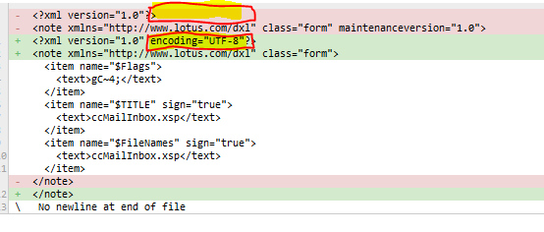

### The ‘maintenanceversion’ attribute will now be filtered out

Previously Dora would force the maintenanceversion attribute to be “1.0” from now on we will simply filter it out.

Example of removal of maintenanceversion

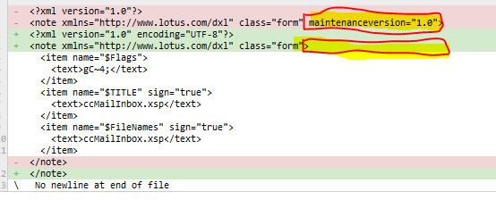

**WARNING**: It is possible that there is a SIGNIFICANT change on the same line as the maintenance version. Be sure to scan the whole line to double check that any other changes are ones that you also want to commit.  
An example is in the picture below, the removal of maintenanceversion is not significant, however on the same line there IS a significant change highlighted in blue. The spelling of the alias has changed which is significant to the operation of the system being developed.

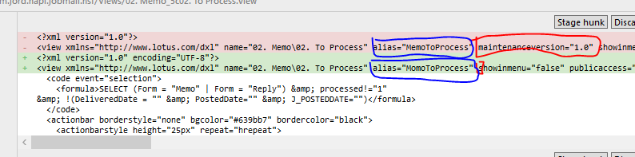

History / Explanation

The reasoning behind the ‘maintenanceversion’ tag is a complicated one. The ‘maintenanceversion’ attribute SHOULD have been filtered from the very start of the Dora project, however it was only discovered to be a problem after we upgraded Domino Designer. This changed the value of maintenanceversion=”1.0” to “1.1” and so on with each designer upgrade. This meant that every file looked like it had changed, even if the developer was to commit this change, if another developer was working on a different designer version, then instantly his system would also report that every file has changed, and it would continue going back and forth for each developer.

Due to the mechanism that Dora worked with, We could not simply start filtering this out as it created an endless loop of git saying “This file has changed, it now does not have a maintenanceversion attribute” but at the point when git attempted to commit the changes, git would also apply the filter to both the checked in file for comparison purposes, and would say “Ok there is no differences when both files are filtered so I won’t check in anything”.

Since Swiper is run totally in the Domino Designer environment, it does not get involved in any of Git’s check-in / commit process. So it will correctly commit the removal of this unwanted attribute, and git will treat it like any other text file.

No Newline at End of File

You may see this one where it does not look like there are any changes at the end, but the difference between the last lines is purely to do with the way the file ends. Previously the files committed with dora may have had an extra new line, which is no longer present in the swiper filtered metadata

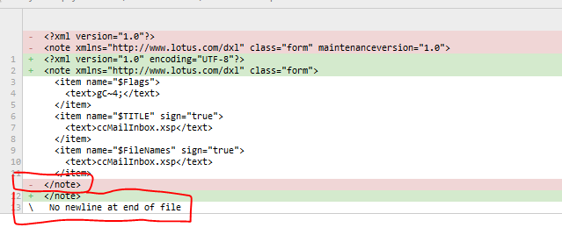

Note that there could also be significant changes involved near the end of the file, so as in the example below I have added a new column to the end of a view. This significant change (blue) appears together with the insignificant change (red) regarding the newline at end of file

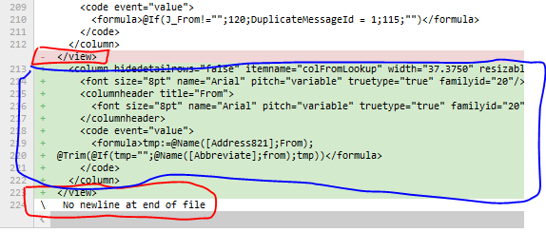

What does it look like in the actual files?

Here the $ represents a new line character  
Example without the Extra New Line

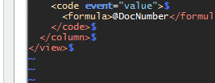

Example with the Extra New Line 

Reordering of Title, Filename $Flags (and similar) items

This insignificant change is not directly related to Swiper or Dora, but just to the random way that the DXL exporter works, sometimes it will output items in a different order.

Notice that all that has happened is that the $Filenames item has switched places with the $Title item. There is no significant change here, and this can be committed.

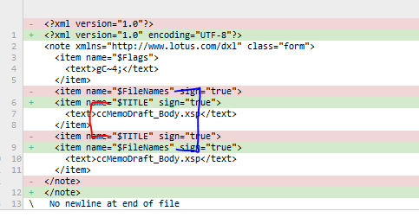

WARNING: If the $Flags item is involved be sure to check whether the content of the ‘text’ node has changed. The funny characters in the text node actually represent properties like ‘Prohibit Design Refresh’. A difference in this value (highlighted yellow) is a significant change as it will affect the behaviour of the system.



## 

## Metadata file was not previously filtered

It is also possible you will find some files that were not previously filtered. The example below shows a file that was not previously filtered by Dora. You can identify this as the xml in the top red section is all aligned to the left margin, and is not indented. You can also see the presence of the nodes such as ‘created’ ‘modified’ and ‘revised’ etc. these are the elements that dora/swiper will filter out.

It is more than likely that this is an ‘insignificant’ change, but you must use your own judgement, for example, have a look at the filename and think whether or not you made any deliberate changes to that designe element.

In most cases this will be fine to commit as the metadata file will now be filtered, which is the desired outcome.

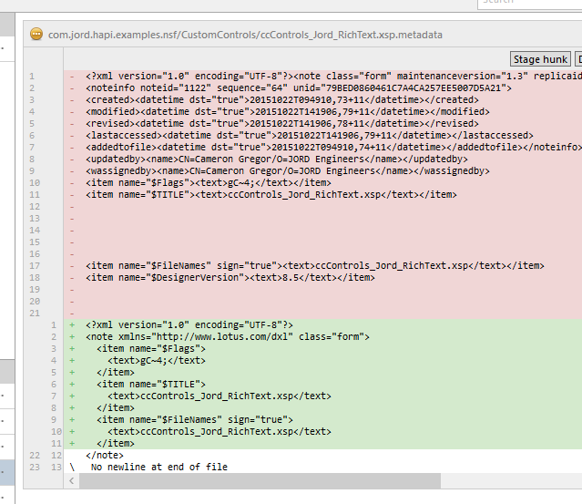

## Committing these Insignificant Changes

If you find these insignificant changes, they can be committed to the repository with a short message ‘metadata changes’. If there are also Significant changes to commit, they should be placed in a separate commit. You can utilise the ‘Stage Lines’ and ‘Stage Hunk‘ functionality of Source tree to do this

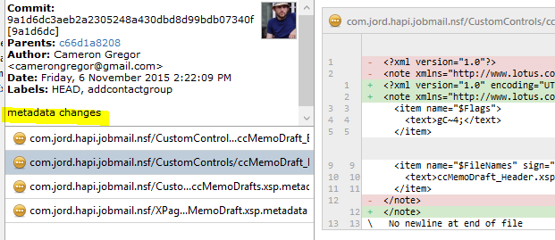

Example Stage hunk :

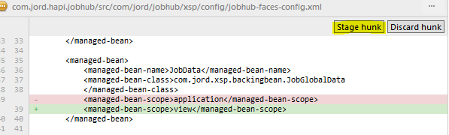

Example Stage Lines: Is shown when lines are selected

